JRC Effectopedia Beta Test Comments

Remark:

As our proxy would not let us connect to the central Effectopedia DB, we installed the effectopedia.aopz locally and worked from there.

Tester: Clemens Wittwehr Comments:

Local files cannot be opened: We created an AOP for Liver Fibrosis and saved it locally as "LiverFibrosisAOP.aopz". When we tried to re-open it afterwards, it did not work. The file is attached to this summary. Only the initial "Effectopedia.aopz" can be opened.

Tester: Brigitte Landesmann Comments

* Deletion of elements

Following the instructions I did not manage to delete anything (had to re-start the whole process to get rid of unwanted elements)

* Chemical info

I tried to complete all the requested info, but besides the InChi_Key no other info was saved after repeated trials (see screen shot below)

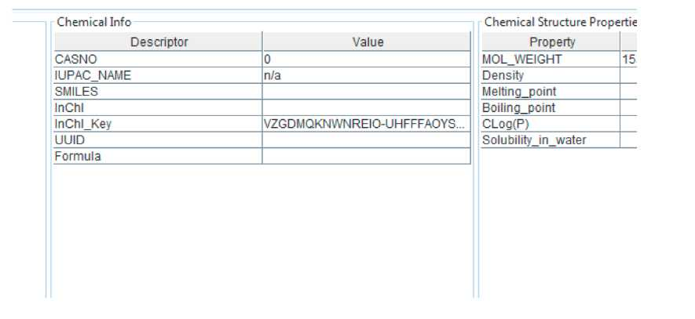

• Test methods

I inserted two methods to test the MIE; these methods appeared then also for all the other KEs (screen shot taken from KE cell death)

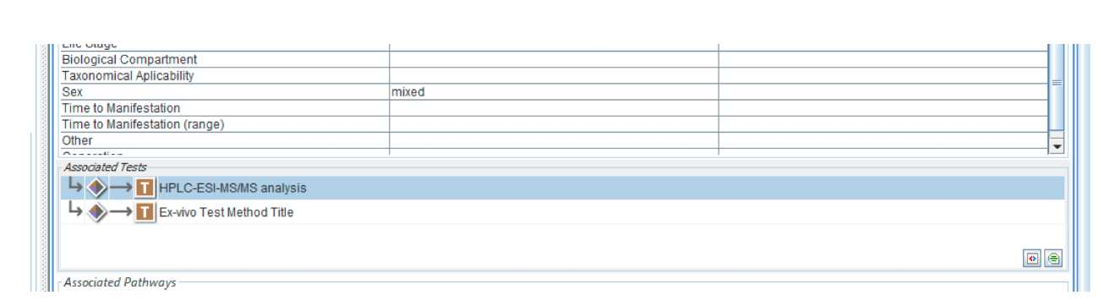

• Adverse Outcome

According to the instructions, the last KE's name can be changed to "assessment endpoint" and

further to "Adverse Outcome" by left click.

I could change to change to assessment endpoint, but not to AO:

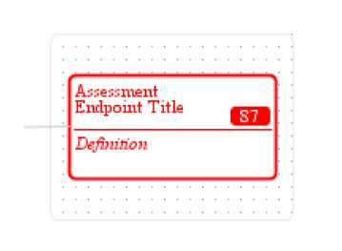

• Lifestage

the scroll down menu mainly offers early cellular stages;

besides "adult", other terms should be added (like fetus, neonate, child, old-age, pregnant woman)

• indirect relationships

how to introduce these? in the descriptions there is the option "indirect", but how to show this on the diagram?

• Essentiality

does not make sense for MIE and AO (see screenshot below)

• WoE

is introduced at each KE, KER box (scroll down menu); but it does not appear on the overview (on the screenshot below it was re-introduced manually on the overview page). Besides, the KE and KER titles appear together with placeholders (cannot be deleted) - see below.

